ASSIGNMENT - 1

SE-OVERVIEW OF IT INDUSTRY

1. What is software? What is software engineering?

🡪 set of instructions executed by any kind of tool.

- The software is basically a set of instructions or commands that tell a computer what to do.

- In other words, the software is a computer program that provides a set of instructions to execute a user's commands and tell the computer what to do.

- For example like MS-Word, MS-Excel, PowerPoint, etc.

-> Software Engineering is use of engineering principles for developing software.

- Software engineering deals with the design, development, testing, and maintenance of software applications.

-Software engineers apply engineering principles and knowledge of programming languages to build software solutions for end users.

- Some examples are Whatsapp, Twitch, Uber, Google Maps, Slack, Instagram, Facebook Messenger, etc.

2. Explain types of Software.

-> There are 5 main types of software :

* System software
* Application software
* Driver software
* Middleware
* Programming software

1) System Software : System software is a program designed to run a computer's hardware and applications and manage its resources, such as its memory, processors, and devices.

- It also provides a platform for running application software.

- System Software is already present in our system.

- e.g calculator, notepad, clock,calendar etc.

2) Application Software : Application software is a kind of software that performs specific functions for the end user by interacting directly with it.

- The sole purpose of application software is to aid the user in doing specified tasks.

- Application can be also called as an APP.

- We have to download the Application software.

- It is not present in the system.

- e.g whatsApp, Instagram, Twitter , Snapchat, Zoom etc.

3) Driver Software : Driver software enables your computer's hardware and operating system to communicate effectively.

- It is also known as Middleware.

- The main function of device driver software is to translate the commands from the operating system into specific instructions for the hardware device.

- It is a programming software which includes compiler and interpreter.

4) Middleware : It is a type of software that mediates between application and system software or between two different kinds of application software.

- For example, middleware enables Microsoft Windows to talk to Excel and Word.

- It is also used to send a remote work request from an application in a computer that has one kind of Operating System , to an application in a computer with a different Operating System.

- It also enables newer applications to work with legacy ones.

5) Programming software : Computer programmers use programming software to write code.

- Programming software and programming tools enable developers to develop, write, test and debug other software programs.

- Examples of programming software include assemblers, compilers, debuggers and interpreters.

- For ex : Turbo C.

3. What is SDLC? Explain each phase of SDLC.

-> SDLC is Software development Life cycle.

- SDLC is a step by step approach to develop any software with high quality , with low cost and in shortest time.

- The goal of SDLC is to minimize project risks by working step by step.

- There are phases of SDLC which helps in successful project making.

-> phases of SDLC are :

* Planning
* Analysis
* Designing
* Implementing
* Testing
* Maintenance

1) Planning : The planning phase includes tasks like :

* cost-benefit analysis
* scheduling
* resource estimation etc.

- The development team collects requirements from several stakeholders such as customers, internal and external experts, and managers to create a software requirement specification document.

- The document sets expectations and defines common goals that aid in project planning.

- The team estimates costs, creates a schedule, and has a detailed plan to achieve their goals.

- Basically, in this phase the whole plan about the software, its making is discussed.

- All these information are gathered in this phase.

2) Analysis : During this phase , the project team analyzes the requirements of the project.

- The team identifies what the end-users need and how the software can meet those needs.

- This stage is important because it helps to ensure that the software meets the needs of the end-users.

- for ex:

-What are the expectations of our users from our software?

3) Designing : The design phase of the Software Development Life Cycle (SDLC) is a critical step in developing the conceptual blueprint of a software project.

- This phase involves transforming the software requirements gathered during the Requirements Analysis phase into a structured design document.

- for ex, we use DFD, Flow chart, ER, Use case diagrams in this phase.

4) Implementation : this is the fourth phase of SDLC.

- In this phase we write the code and implement it.

- The main development part comes under this phase.

- This phase includes the development of the software (Coding) and built it and then implement the same code into action.

-After that , it is send to the testing team to find out the errors.

5) Testing : In this fifth phase of SDLC, the testing is done to ensure that the entire application works according to the customer requirements or not.

- After testing, the QA and testing team might find some bugs or defects and communicate the same with the developers.

- Then the developers solves the problem and make it easy for users to use.

- Testing team (QA) checks the whole development and finds all the errors .

- Their main work is to find errors.

6) Maintenance : The purpose of the maintenance phase is to provide three key outcomes:

* maintain software functionality
* make upgrades to the coding
* ensure any repairs needed to the software are completed.

- These are the main tasks of this phase.

- Maintenance is the crucial part of the SDLC.

- New updates must come after some time.

4. What is DFD? Create a DFD diagram on Flipkart.

-> DFD is data flow diagram.

- The flow of data of a system or a process is represented by DFD.

- It is a graphical tool that is used to communicate with users etc.

- A data flow diagram (DFD) is a graphical or visual representation that uses a standardized set of symbols and notations to describe a business's operations through data movement.

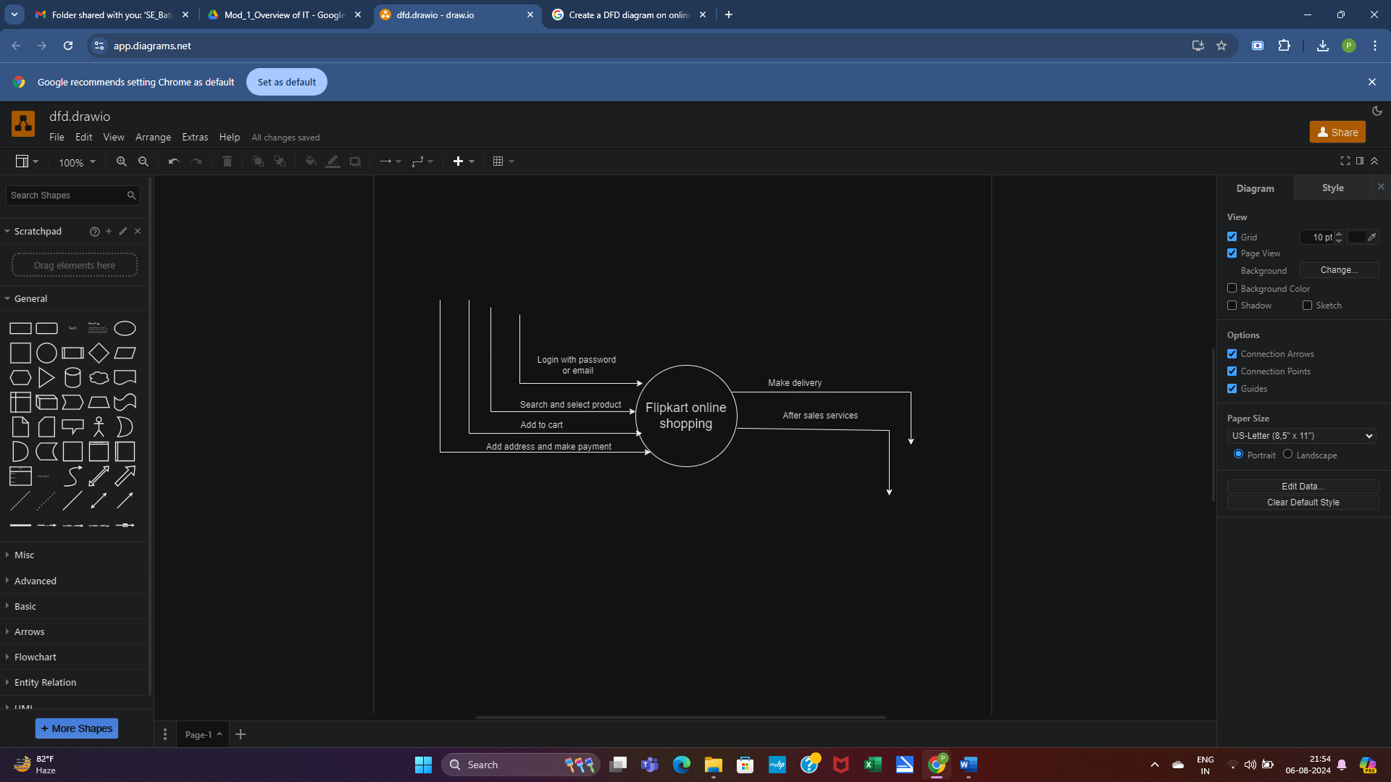

0 – level dfd

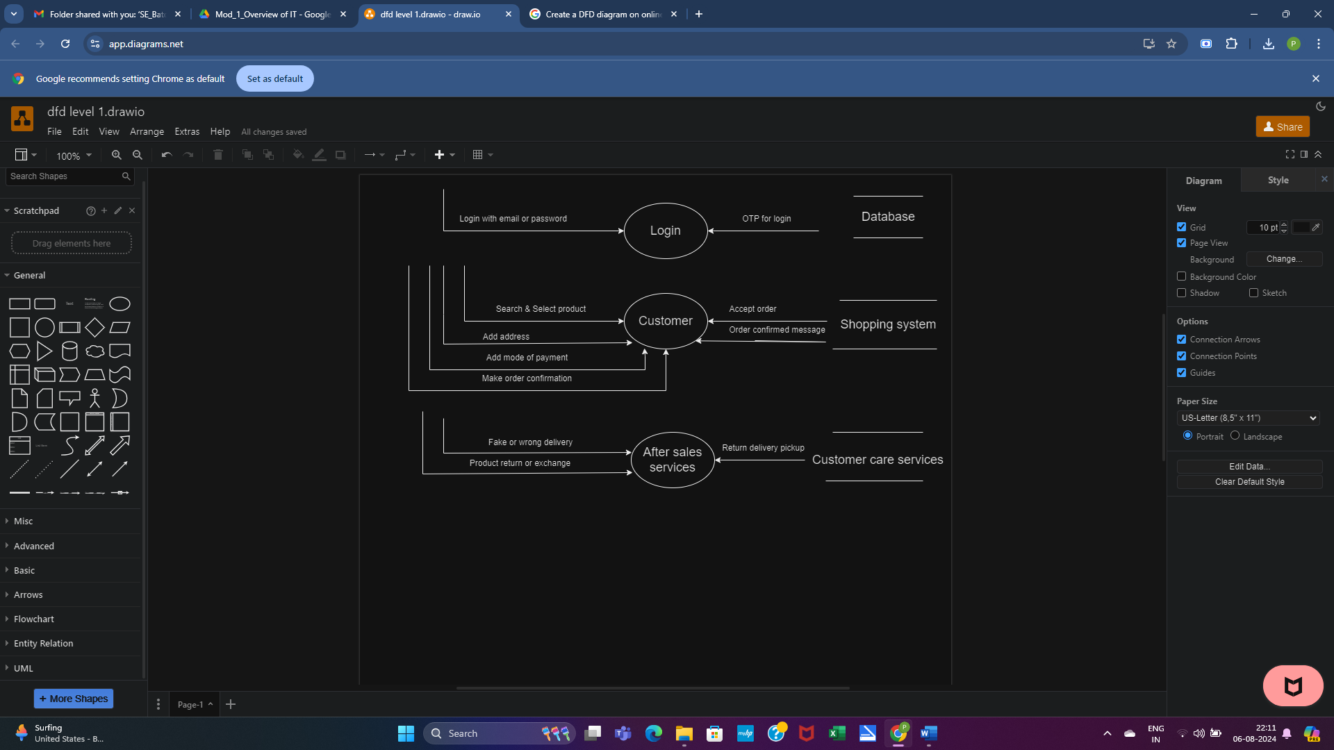

1 – level dfd

5. What is Flow chart? Create a flowchart to make addition of two numbers.

-> A flowchart is a type of diagram that represent a process.

- It is a diagrammatic representation of process.

- Flowcharts are basically used to visualize the sequence of actions.

- They use symbols, shapes, and arrows to illustrate how one step leads to another.

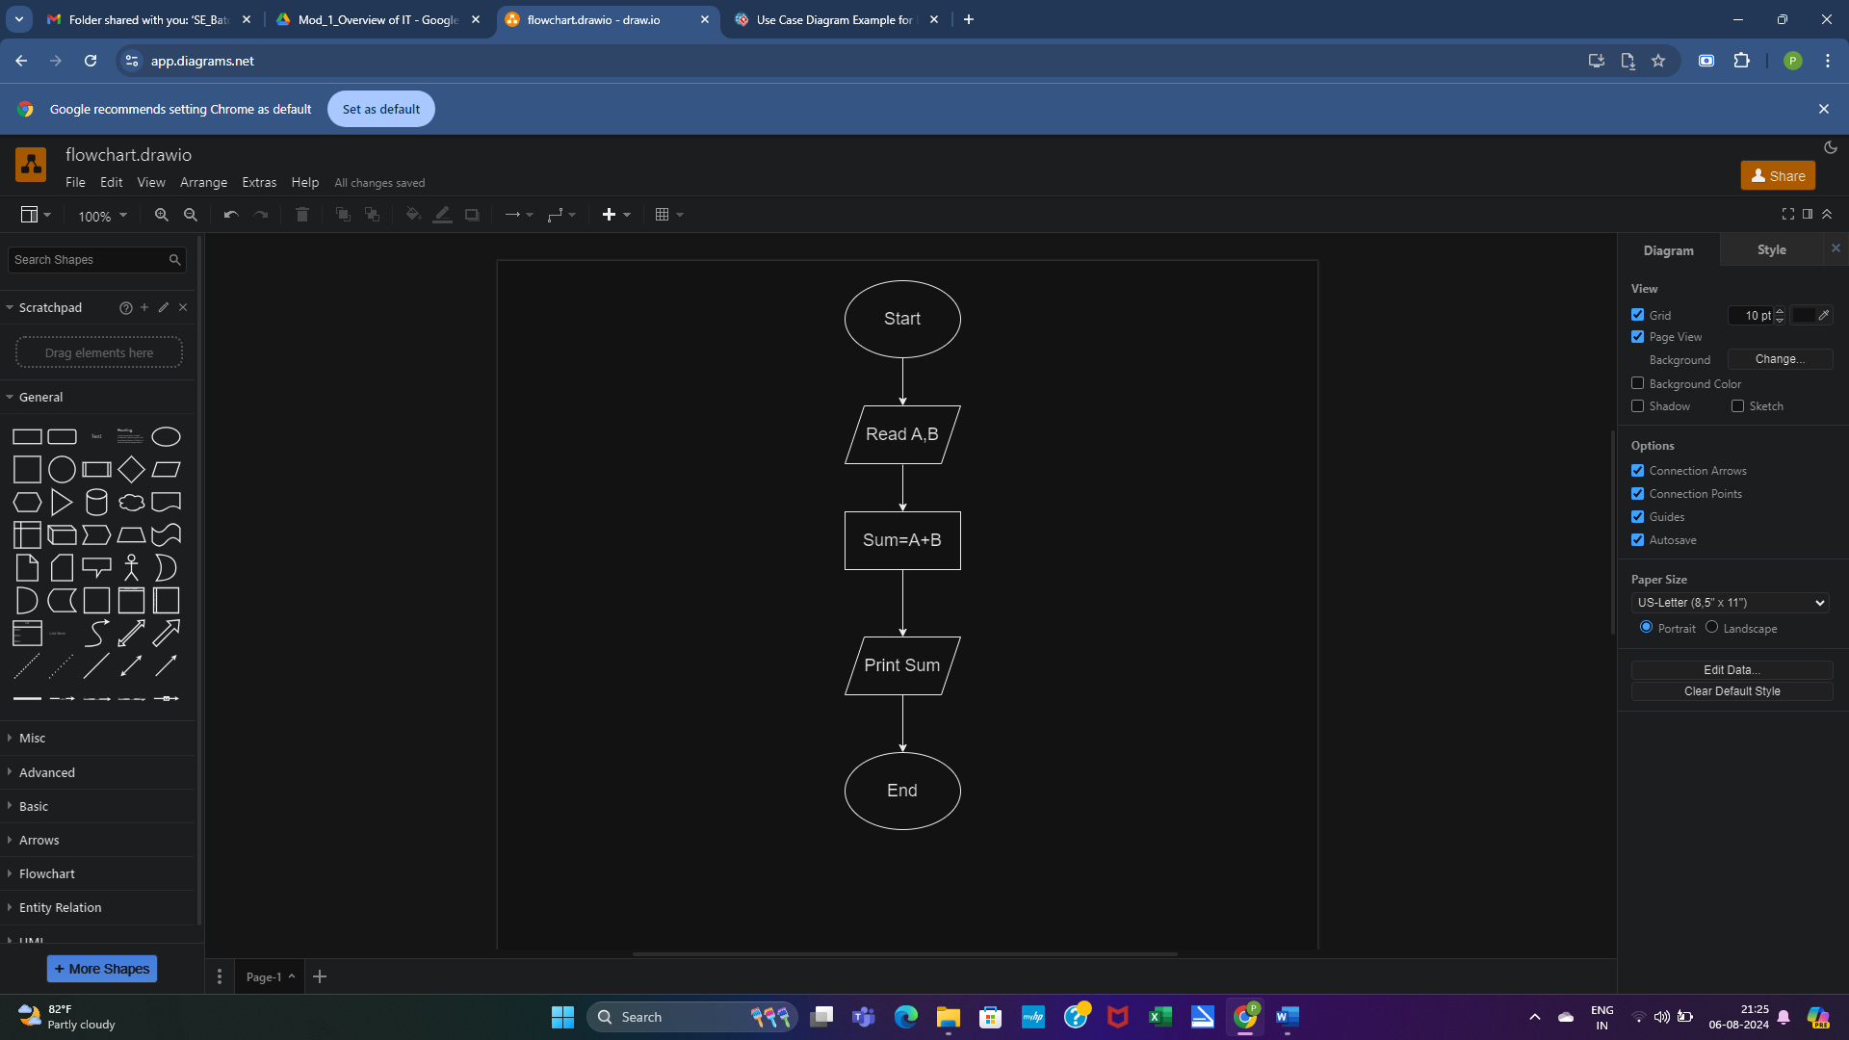

Flowchart

6. What is Use case Diagram? Create a use-case on bill payment on Paytm.

-> A Use Case Diagram is a vital tool in system design, it provides a visual representation of how users interact with a system.

- It serves as a blueprint for understanding the functional requirements of a system from a user’s perspective, aiding in the communication between stakeholders and guiding the development process.

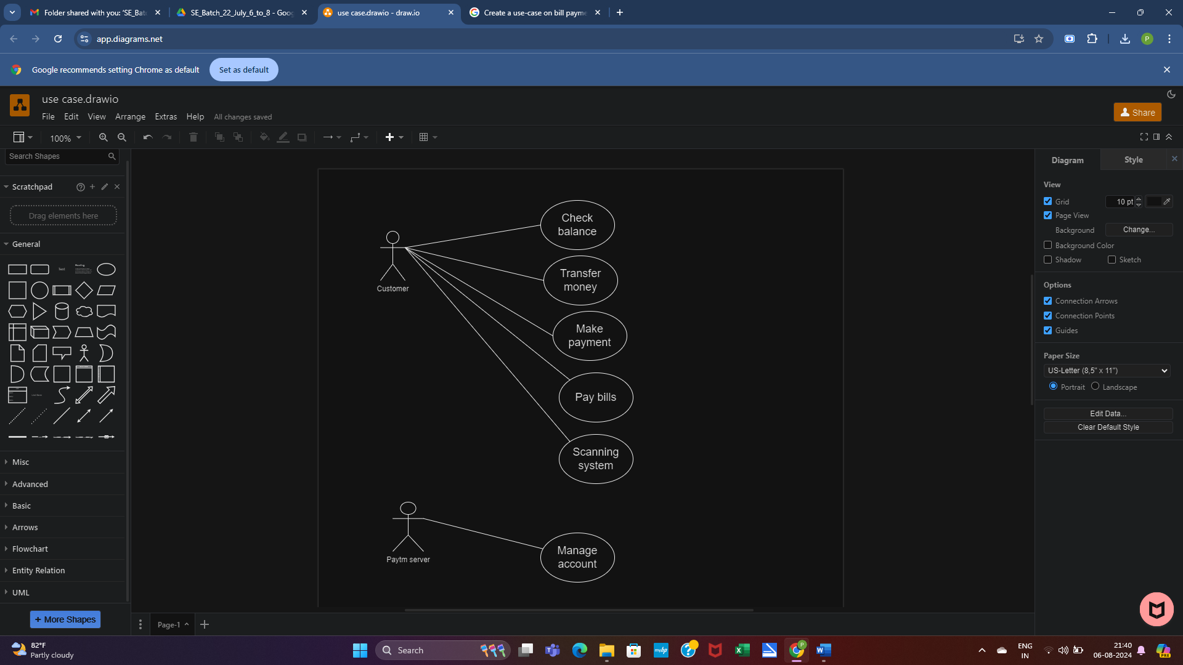

Use – Case diagram